EXERCISE: CREATING MICROSERVICES FOR ACCOUNT AND LOAN

**ACCOUNTAPPLICATION.JAVA**

package com.cognizant.account;

import org.springframework.boot.SpringApplication;

import org.springframework.boot.autoconfigure.SpringBootApplication; public class AccountApplication {

public static void main(String[] args) {

SpringApplication.run(AccountApplication.class, args);

}

}

**ACCOUNTRESPONSEPRINTER.JAVA**

package com.cognizant.account.controller;

import org.springframework.web.bind.annotation.GetMapping; import org.springframework.web.bind.annotation.PathVariable; import org.springframework.web.bind.annotation.RestController; import java.util.Map;

public class AccountResponsePrinter {

public Map<String, Object> getAccount(@PathVariable String number) { System.out.println(" \"number\": \"" + number + "\",");

System.out.println(" \"type\": \"savings\","); System.out.println(" \"balance\": 234343");

"type", "savings", "balance", 234343

);

}

}

**CONSOLE OUTPUT**

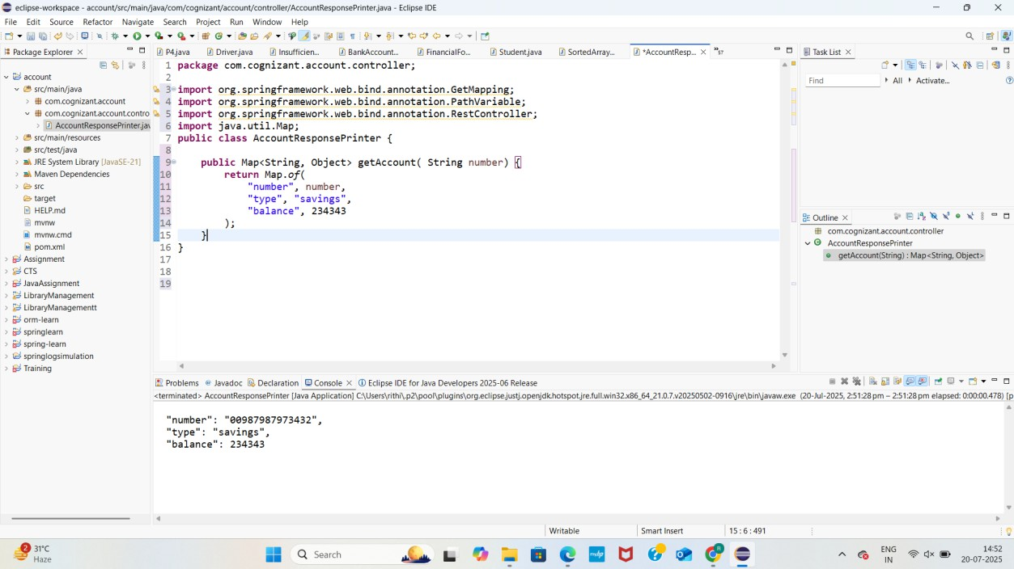

**LOCALHOST OUTPUT**

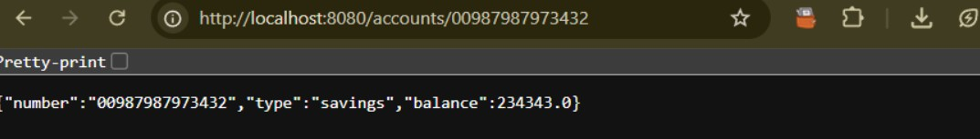

**LOANAPPLICATION.JAVA**

package com.cognizant.loan;

import org.springframework.boot.SpringApplication;

import org.springframework.boot.autoconfigure.SpringBootApplication; public class LoanApplication {

public static void main(String[] args) { SpringApplication.run(LoanApplication.class, args);

}

}

**LOANJSONPRINTER.JAVA**

package com.cognizant.loan.controller;

import org.springframework.web.bind.annotation.GetMapping; import org.springframework.web.bind.annotation.PathVariable; import org.springframework.web.bind.annotation.RestController; import java.util.Map;

public class LoanController {

public Map<String, Object> getLoan(@PathVariable String number) { System.out.println(" \"number\": \"" + number + "\",");

System.out.println(" \"type\": \"car\","); System.out.println(" \"loan\": 400000,");

System.out.println(" \"emi\": 3258,");

System.out.println(" \"tenure\": 18");

"type", "car", "loan", 400000,

"emi", 3258,

"tenure", 18

);

}

}

**CONSOLE OUTPUT**

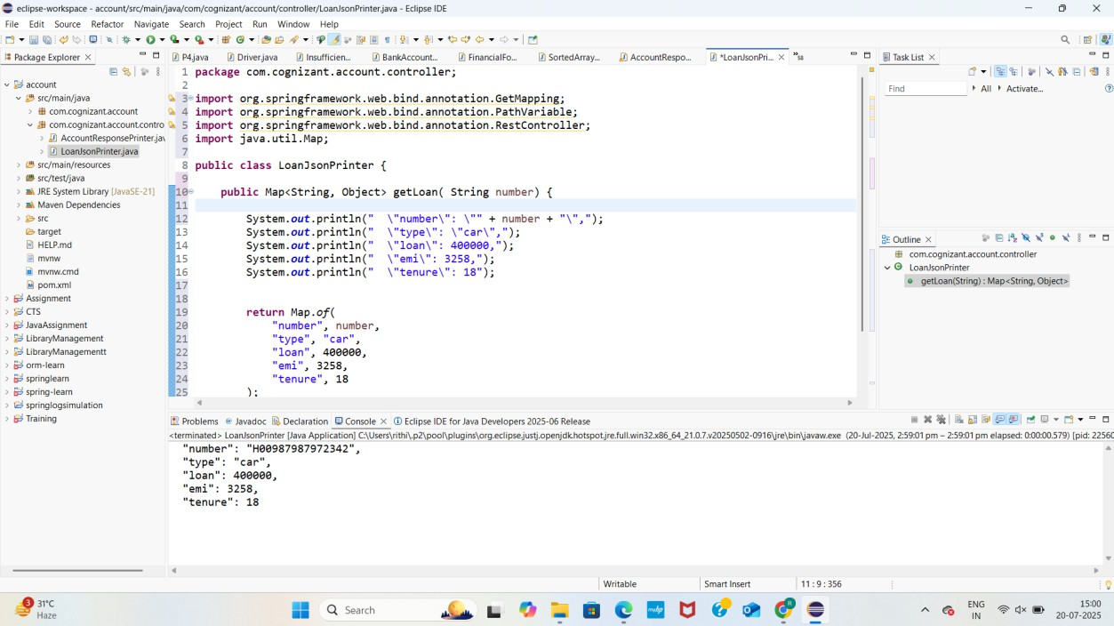

**LOCALHOST OUTPUT**

